Tag vs Element

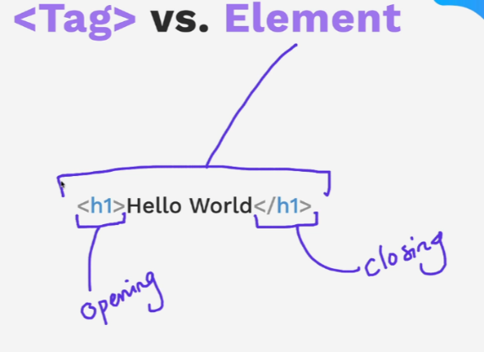

Section Headings

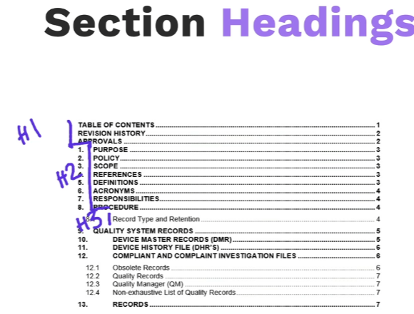

Paragraph elements stack on top of one another

Lorem Ipsum

[www.lipsum.com](http://www.lipsum.com)

or in vscode in side the tags use word lorem followed by how many words with no space

lorem5

others

<https://baconipsum.com/>

15 Self Closing Tags or void elements

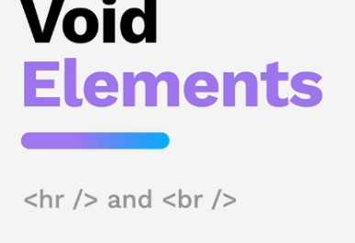

Difference checker tool <https://www.diffchecker.com/>

16 Movie project

<https://www.rogerebert.com/>

requirements

3 movies

The Barbie Movie

Dune – the original

Sound of Music

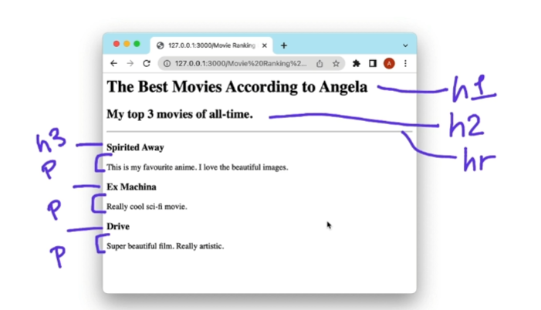

Restart here

<https://www.udemy.com/course/the-complete-web-development-bootcamp/learn/lecture/37349766#overview>